Teste com condigo em R em formato .docx

Calos Daniel

2024-05-22

# Este é um codigo simples em R para testar a execusão do quarto

show("hello world")

[1] "hello world"

library(ggplot2)  
summary(CO2)

Plant Type Treatment conc uptake   
 Qn1 : 7 Quebec :42 nonchilled:42 Min. : 95 Min. : 7.70   
 Qn2 : 7 Mississippi:42 chilled :42 1st Qu.: 175 1st Qu.:17.90   
 Qn3 : 7 Median : 350 Median :28.30   
 Qc1 : 7 Mean : 435 Mean :27.21   
 Qc3 : 7 3rd Qu.: 675 3rd Qu.:37.12   
 Qc2 : 7 Max. :1000 Max. :45.50   
 (Other):42

ggplot(CO2, aes(Treatment, uptake)) +  
 geom_boxplot()

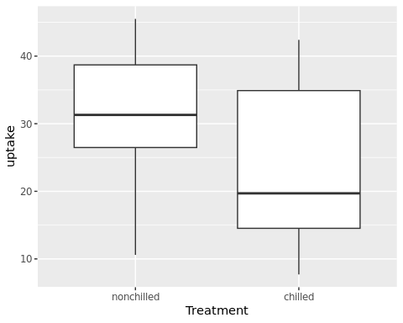

### por algum motivo infelizmente eu não consigo rodar o ggplot2 apenas chamando a biblioteca mãe, como o tydyverse. acontece um erro na execussão

show("hello world")  
  
library(tydyverse)  
summary(CO2)  
  
ggplot(CO2, aes(Treatment, uptake))   
 geom_boxplot()

info_2024/posts/post-with-code/index.qmd –no-browser –no-watch-inputs ERROR: Error reading metadata from /home/daniel/ATA_bioinfo_2024/posts/post-with-code/index.qmd.

can not read a block mapping entry; a multiline key may not be an implicit key at line 15, column 1:

ERROR: YAMLError: can not read a block mapping entry; a multiline key may not be an implicit key at line 15, column 1:

Stack trace:

at generateError (file:///opt/quarto/bin/quarto.js:10480:12)  
at throwError (file:///opt/quarto/bin/quarto.js:10483:11)  
at readBlockMapping (file:///opt/quarto/bin/quarto.js:11107:24)  
at composeNode (file:///opt/quarto/bin/quarto.js:11299:84)  
at readDocument (file:///opt/quarto/bin/quarto.js:11413:5)  
at loadDocuments (file:///opt/quarto/bin/quarto.js:11448:9)  
at load (file:///opt/quarto/bin/quarto.js:11453:23)  
at parse2 (file:///opt/quarto/bin/quarto.js:11463:12)  
at parseWithNiceErrors (file:///opt/quarto/bin/quarto.js:19695:16)  
at readYamlFromMarkdown (file:///opt/quarto/bin/quarto.js:19635:26)